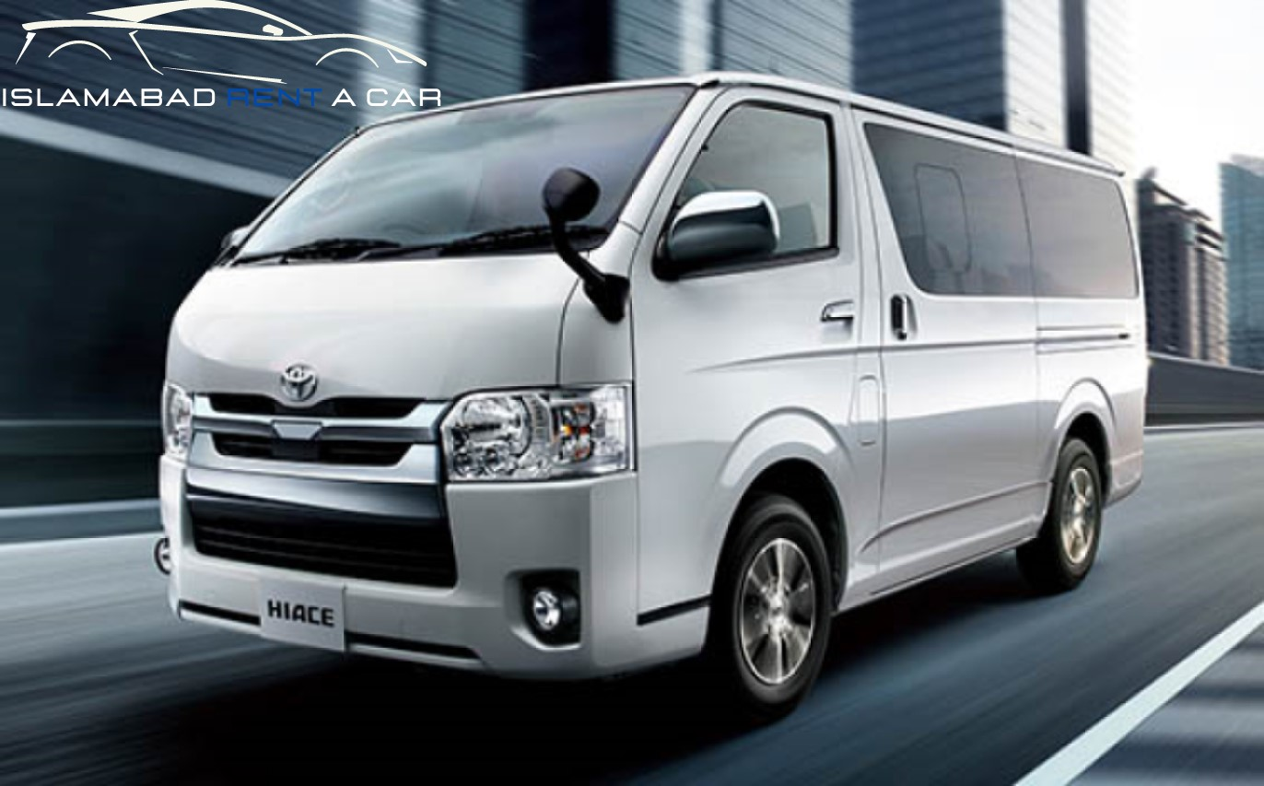

Get Toyota Hiace for Rent in Islamabad & Rawalpindi!

Are you looking for Toyota Hiace for rent in Islamabad and Rawalpindi? If so, you're in luck! With a wide selection of quality Toyota Hiace vehicles available for rent in both Islamabad and Rawalpindi, you can be sure to find the perfect vehicle for your needs. Whether you're looking for a reliable and efficient family car or a spacious and comfortable business vehicle, we have the ideal Toyota Hiace for rent in Islamabad and Rawalpindi to meet your needs.

The car rental process
Renting a car can be an excellent way to travel and explore new places. If you're looking for Toyota Hiace for rent in Islamabad and Rawalpindi, you're lucky, as several rental companies offer this type of vehicle. To get started, you'll need to ensure you meet the requirements, including having valid driver's licenses and insurance. Once these requirements are fulfilled, you can begin renting a car.
When you're ready to make your reservation, you'll need to provide your contact information and choose which vehicle you want to rent. Many rental companies offer various options, from economy vehicles to luxury cars, so knowing precisely what vehicle will best suit your needs is essential. If you're looking for a Toyota Hiace for rent in Rawalpindi or Islamabad, make sure to ask about the availability of this type of vehicle.
Once you have chosen the right car for your needs, you'll need to sign the rental agreement and pay the required deposits. Be sure to read the terms and conditions carefully before signing anything, and make sure you understand the policies regarding late returns, damages, and other essential topics.
After your rental agreement is signed and your deposits are paid, you'll be ready to pick up your car! Inspect the vehicle thoroughly before taking it off the lot, and remember to fill up the tank before you return it.
Following these steps will ensure a smooth and stress-free car rental process. Renting a car can be an exciting and rewarding experience, so choose the right vehicle for your needs and enjoy your journey!

The benefits of renting a car
Renting a car can be a great way to get around town or take a more extended road trip without purchasing and maintaining your own vehicle. Renting a car allows you to experience the convenience of a vehicle without the commitment of ownership. You'll also have access to various vehicles for different needs, from fuel-efficient sedans to luxurious SUVs and even vans for rent in Islamabad!
Renting a car can be especially helpful if travelling on business and needing reliable transportation to meetings or events. It also allows you to explore new cities or attractions without relying on public transit or expensive cab rides. Plus, you can easily adjust the length of your rental period depending on how long you need it.
Another benefit of renting a car is that you don't have to worry about maintenance costs or repairs. Most rental companies offer insurance and roadside assistance with their rental agreements, so you won't have to worry about unexpected expenses if something goes wrong while driving. Plus, you won't have to put any money down when you rent, making it an affordable option for short-term trips.

The types of cars available for rent
When renting a car in Islamabad and Rawalpindi, you have many options. From sedans to SUVs, there is something for everyone. One of the most popular choices is the Toyota Hiace Van for rent in Islamabad. It's a reliable, comfortable, affordable vehicle with plenty of cargo space. The Hiace is perfect for long-distance drives or simply getting around town. It's also great for groups or large families because it can comfortably fit up to nine passengers. You can also get a customized Hiace with features like an extra large backseat, reclining front seats, and an extended storage area. The prices for a Hiace rental in Islamabad are reasonable, so it's an excellent option for those on a budget.

Van for rent in Islamabad
Are you looking for a van for rent in Islamabad? Then look no further than Toyota Hiace! Toyota Hiace is one of the most reliable and comfortable vans available for rent in Islamabad. It is perfect for family vacations, business trips or just a weekend away.
Toyota Hiace offers excellent features like a spacious interior, smooth ride quality and top-notch safety. It has an ergonomic seating arrangement, ample luggage space and a powerful engine. The exterior is sleek and modern, making it an excellent choice for any occasion.
Regarding affordability, Toyota Hiace has a competitive edge over its competitors. Its rental rate is very reasonable, and you can expect great value. You can expect a safe and enjoyable journey without breaking the bank with Toyota Hiace.
Toyota Hiace should be at the top of your list for those looking for a reliable van for rent in Islamabad. It offers comfort and reliability that is hard to find in any other van rental service in Islamabad. So, if you plan a trip to Islamabad, remember to check out Toyota Hiace!

The cost of renting a car
Renting a car can be affordable if you need a vehicle for a short period. The cost of renting a car in Islamabad and Rawalpindi depends on the type of car you choose, the duration of your rental, and other factors.
If you're looking for a van for rent in Islamabad, the cost will depend on the size and model of the truck, as well as the number of days you need it for. Generally, prices for vans start from around Rs. 10,000 for up to three days. However, you can get discounts if you rent the van for extended periods.
The cost of renting a car may also be affected by the time of year you plan to rent it, as certain times of the year have higher demand and may therefore have higher rates. It's also worth keeping in mind that many car rental companies offer discounted rates for frequent renters or those who rent cars in bulk.
Finally, it's important to remember that the cost of renting a car will include not only the actual car rental price but also taxes and fees related to registration and fuel charges. It's essential to read the fine print carefully before signing the agreement to know the total cost before committing to a rental.

